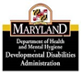 Self-directed Services
Developmental Disabilities Administration

August 2015

This document was slightly modified from a document developed by the Rhode Island Statewide Quality Consortium Health and Safety Committee. The Maryland Developmental Disabilities Administration extends its sincere appreciation to the Rhode Island Division of Developmental Disabilities for its willingness to share its resources.

Introduction
This tool has been developed to be a resource for individuals with developmental disabilities to use for planning purposes to ensure their health and safety, as well as encouraging individual choice and actions to minimize or prevent of serious types of incidents. Although initially obtained as a tool for individuals developing Self-direction Individual Plans and Budgets as part of a participant-directed model of service delivery, we encourage its use for planning for individuals entering traditional provider-managed services as well.

Purposes of the Tool:
- To heighten safety planning awareness, to identify and address unreasonable risk in order to prevent potential harm from occurring and to enhance the quality of life of the person
- To directly involve the person, his/her family/legal guardian, and other individuals who know him/her best to describe support services, strategies or interventions necessary in each risk area to keep the person safe from serious harm and promote good health, independence and opportunity to live a good life. Each person’s needs will vary depending upon his/her life experiences, abilities and environment.
- To identify potential areas of risk of serious harm to a person in the following areas: Community Safety, Health/Medical, Sexuality/ Relationships, Abuse, Financial Exploitation, Behaviors, Home Environment, Fire Safety, Personal Care/Daily Living, Mental Health, Police Involvement, Informed Consent, Support Services and Other

Included on the next pages are various variables of potential risk/safety concerns for serious harm or vulnerability of a person with a developmental disability for an illness, accident or a serious incident. It is recognized that in some instances it may be difficult to prevent harm from occurring involving a person with a disability. However, there are some precautions or interventions that can be identified and implemented in order to minimize serious harm. The challenge for providers/agencies is to support each person so he/she can make their own decisions and choices for how they want to live their lives while facing minimal exposure to risk of serious harm. The ability of the person to make informed choices must be balanced with a reasonably safe environment. It is the responsibility of all of us to assure that people with disabilities and their families are provided with access to adequate quality information in order to make appropriate decisions in areas affecting their personal lives.

Safety/Risk Assessment Areas

- COMMUNITY SAFETY
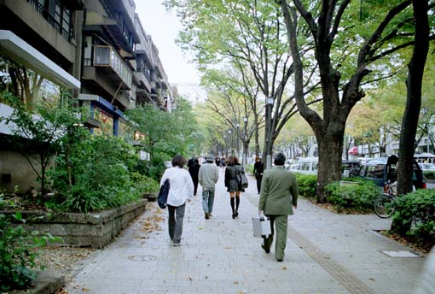

This area is intended to assess the person’s capacity to be relatively safe in various locations within the community. Thought should be given to address whether or not the person has or can learn the necessary basic skills to handle themselves in specific situations. Areas for consideration would include the following:

- possession of personal identification and understanding of this information,
- knowledge of emergency telephone numbers/contact people,
- ability to use public telephone, personal cell phone, etc. for emergencies
- need for direct staff supervision or “eyes-on” supervision for specific timeframes/locations,
- neighborhood/street safety, knowledge of traffic lights, use of cross walks and capacity to safely cross streets, etc.
- ability to be alone in the community,
- appropriate interaction with strangers,
- ability to protect self in unsafe situations…capacity to say “no”, call for help, etc,
- safe use of public transportation,
- understanding and ability to access police, hospital, fire, etc. when needed,
- history of elopement,
- frequency of time in unsafe locations,
- daytime safety vs. evening safety,
- any other areas of concern

Safety/Risk Areas  Each area includes a list of indicators for possible risk or concern relating to the individual. | Description of Concern  (Indicate “Yes” or “No” for each area listed. If “Yes”, write a brief narrative of the specific issue or concern posing a risk, the circumstances and frequency.) | Supports/Action Necessary to Address Risk/Safety Concerns  (Describe interventions or services necessary to address each identified safety/risk area) | Person Responsible and Timeframe  (List name and start date for implementation) | Evaluation of Effectiveness  (Describe what worked, what didn’t, person’s impressions of intervention and comments of others)

1. Community Safety
Areas for consideration:

Safety/Risk Assessment Areas

2. HEALTH/MEDICAL CARE

This area is intended to assess the person’s health and medical care needs. Areas for consideration would include the following:
- weight control or need for exercise, adequate nutrition (dietary needs),
- seizure control,
- aspiration, risk of choking, ability to eat/chew,
- allergies,
- history of falls, gait or balance disorder,
- frequent pneumonia,
- frequent urinary track infections,
- Gastroesophageal reflux disease (GERD),
- psychotropic medications,
- dental care,
- medically fragile condition,
- specific mobility needs,
- constipation problems,
- agreement/follow through to take medications,
- seeking medical advice, keeping medical appointments, consent for medical treatment,
- preventative screenings (e.g. PAP test, colonoscopy, etc.)
- smoking,
- diabetes,
- accessing medical care or specialists,
- responding to emergency/ medical care,
- safe use of medical equipment,
- any other areas of concern
Safety/Risk Areas  Each area includes a list of indicators for possible risk or concern relating to the individual. | Description of Concern  (Indicate “Yes” or “No” for each area listed. If “Yes”, write a brief narrative of the specific issue or concern posing a risk, the circumstances and frequency.) | Supports/Action Necessary to Address Risk/Safety Concerns  (Describe interventions or services necessary to address each identified safety/risk area) | Person Responsible and Timeframe  (List name and start date for implementation) | Evaluation of Effectiveness  (Describe what worked, what didn’t, person’s impressions of intervention and comments of others)

2. Health/Medical Care
Areas for consideration:

Safety/Risk Assessment Areas

Relationships/Sexuality



This area is intended to assess the person’s understanding of relationships and sexuality issues. This includes identifying the person’s capacity to be involved in relationships and to understand various boundary issues relating to sexual behavior and contacts. Areas for consideration would include the following:
- ability to develop appropriate friendships,
- understanding of healthy sexual choices and lifestyles,
- understanding of legal or safe social behavior,
- has opportunities for dating,
- general understanding of the concept of privacy,
- ability to communicate appropriate words that relate to relationship boundaries, appropriate touch, space, and any unwanted sexual contacts
- need for sex education or individual counseling,
- capacity for developing healthy sexual relationships,
- displays sexually risky behavior, inappropriate sexual behavior in public,
- knowledge of birth control/safe sex (avoiding STD’s),
- understanding when to say “no” and recognition other person has capacity to say “no”,
- understanding of how to stop unwanted sexual advances,
- knowledge of and proper use of sexually explicit materials,
- healthy/safe understanding of masturbation,
- understanding of how pregnancy occurs and need for use of safe sex,
- knowledge of responsibilities of parenthood,
- general understanding of internet safety and potential dangers of the internet,
- other areas of concern

Safety/Risk Areas  Each area includes a list of indicators for possible risk or concern relating to the individual | Description of Concern  (Indicate “Yes” or “No” for each area listed. If “Yes”, write a brief narrative of the specific issue or concern posing a risk, the circumstances and frequency.) | Supports/Action Necessary to Address Risk/Safety Concerns  (Describe interventions or services necessary to address each identified safety/risk area) | Person Responsible and Timeframe  (List name and start date for implementation) | Evaluation of Effectiveness  (Describe what worked, what didn’t, person’s impressions of intervention and comments of others)

3. Relationships/Sexuality
Areas for consideration…

Safety/Risk Assessment Areas
4. Abuse


This area is intended to assess the person’s vulnerability to possible abuse, neglect, mistreatment or other serious type of incidents that may cause serious harm to the individual. This area would review any prior history of abuse, any current areas of concern as well as the likely potential for risk for abuse in the person’s future . Areas for consideration would include the following:
- history of child victimization,
- history of adult victimization,
- vulnerability due to limited communication skills, etc.,
- ability to understand vocabulary and the meaning of words that relate to boundaries within various relationships and contact with people, appropriate touch, space and healthy sexuality,
- flashbacks of prior traumatic events,
- potential for domestic violence,
- caregiver stress, problems, neglect,
- proximity/contact with potential abusers,
- caregiver/family concerns,
- reluctance to communicate abuse or potential for abuse,
- sexually active behavior or risky relationships,
- fear of specific individual in current relationship,
- dependence on others for personal care,
- inappropriate behaviors and relationships,
- potential for abusing others,
- history of abusing others,
- use of internet chat rooms, potentially risky websites, etc.
- limited family resources for emergency assistance when needed
- other areas of concern
Safety/Risk Areas  Each area includes a list of indicators for possible risk or concern relating to the individual | Description of Concern  (Indicate “Yes” or “No” for each area listed. If “Yes”, write a brief narrative of the specific issue or concern posing a risk, the circumstances and frequency.) | Supports/Action Necessary to Address Risk/Safety Concerns  (Describe interventions or services necessary to address each identified safety/risk area) | Person Responsible and Timeframe  (List name and start date for implementation) | Evaluation of Effectiveness  (Describe what worked, what didn’t, person’s impressions of intervention and comments of others)

4. Abuse
Areas for consideration…

Safety/Risk Assessment Areas

- Financial Exploitation


This area is intended to assess the person’s potential to be taken advantage of in terms of their financial assets, such as SSI/SSDI checks and other checks/income, banking accounts, credit cards, cash on hand, etc. Areas for consideration would include the following:

- understanding of the value money,
- having access to own funds for personal use,
- ability to manage finances and conduct banking,
- ability to safely carry money,
- capacity to pay bills,
- ability to keep records/receipts on money spent,
- use of credit cards,
- potential to be manipulated/taken advantage of in the area of finances,
- safe/reasonable use of ATM card,
- knowingly gives money away inappropriately,
- pays unreasonable share of costs,
- knowing what to do if robbed/assaulted,
- history of credit card debt,
- vulnerable to rep payee,
- other areas of concern

Safety/Risk Areas  Each area includes a list of indicators for possible risk or concern relating to the individual | Description of Concern  (Indicate “Yes” or “No” for each area listed. If “Yes”, write a brief narrative of the specific issue or concern posing a risk, the circumstances and frequency.) | Supports/Action Necessary to Address Risk/Safety Concerns  (Describe interventions or services necessary to address each identified safety/risk area) | Person Responsible and Timeframe  (List name and start date for implementation) | Evaluation of Effectiveness  (Describe what worked, what didn’t, person’s impressions of intervention and comments of others)

5. Financial Exploitation
Areas for consideration…

Safety/Risk Assessment Areas
- Behaviors

This area is intended to assess the person’s potential to display behaviors that may be harmful to self or to others. Areas for consideration would include the following:
- self injurious behaviors,
- aggressive actions, destructive behaviors,
- pica (eating non-food items),
- suicidal gestures,
- fire setting,
- drug or alcohol abuse,
- symptoms of mental health condition/illness,
- need for professional support (counseling, psychiatrist, etc.),
- changes in eating habits,
- environmental factors affecting behaviors…stressors…loss of family, home, pet, friend, etc.,
- threats or aggressive actions to self or others,
- attempts at elopement,
- multiple behavioral problems,
- unsafe sexual behaviors,
- sexual offender behaviors,
- limitations in functional communication,
- use of or access to weapons, handgun, etc.
- hoarding behaviors,
- poor treatment of animals,
- refusal of services,
- other possible criminal behavior,
- other areas of concern

Safety/Risk Areas  Each area includes a list of indicators for possible risk or concern relating to the individual | Description of Concern  (Indicate “Yes” or “No” for each area listed. If “Yes”, write a brief narrative of the specific issue or concern posing a risk, the circumstances and frequency.) | Supports/Action Necessary to Address Risk/Safety Concerns  (Describe interventions or services necessary to address each identified safety/risk area) | Person Responsible and Timeframe  (List name and start date for implementation) | Evaluation of Effectiveness  (Describe what worked, what didn’t, person’s impressions of intervention and comments of others)

6. Behaviors
Areas for consideration…

Safety/Risk Assessment Areas
- Home Environment

This area is intended to access the person’s ability to be safe within their own home and to understand what to do if there were an emergency. Areas for consideration would include the following:
- ability to stay alone in the home/apartment,
- capacity to protect self in unsafe situations, ability to call for help or use 911,
- knowledge of how to access contact person(s) for emergencies or staff problems(person doesn’t show up for work, staff person becomes ill, etc.),
- understanding safe kitchen practices, safe cooking skills,
- ability to maintain sanitary conditions,
- awareness of security and safety devices,
- ability to bathe,
- knowledge of using safe water temperatures,
- knowledge of and use of telephone, cell phone for calls for help or emergencies,
- knowledge of basic first aid,
- identifying and communicating to the appropriate person any potential building hazards,
- knowledge of fire appliances,
- general understanding of proper response for any phone solicitation,
- smoking safety,
- ability for using keys to home/apartment,
- knowledge of what to do in the event of any power outages,
- appropriate response for interaction with strangers,
- appropriate response to people coming into the home,
- appropriate relationships with neighbors, general skills for living safely in neighborhood,
- problems with social isolation,
- need for other housing given problems/crisis with current living situation,
- knowledge of internet safety,
- other areas of concern

Safety/Risk Areas  Each area includes a list of indicators for possible risk or concern relating to the individual | Description of Concern  (Indicate “Yes” or “No” for each area listed. If “Yes”, write a brief narrative of the specific issue or concern posing a risk, the circumstances and frequency.) | Supports/Action Necessary to Address Risk/Safety Concerns  (Describe interventions or services necessary to address each identified safety/risk area) | Person Responsible and Timeframe  (List name and start date for implementation) | Evaluation of Effectiveness  (Describe what worked, what didn’t, person’s impressions of intervention and comments of others)

7. Home Environment
Areas for consideration…

Safety/Risk Assessment Areas
- Fire Safety


This area is intended to assess the person’s fire safety skills and understanding of what to do in the event of a fire. Areas for consideration would include the following:
- capacity for understanding of and checking for possible safety hazards within the person’s living arrangement,
- knowledge of what to do in case of fire or fire drill, ability to independently exit a building,
- understanding proper response for smoke alarms,
- safe use of electrical circuits,
- ability to call 911 in an emergency,
- using safe smoking habits,
- understanding the dangers of fires,
- skills for cooking safety,
- knowledge of escape route exits to evacuate,
- proper use of space heaters,
- proper use of extension cords and electrical outlets,
- storage and use of flammable items, candles, etc.,
- safe use of medical equipment,
- other areas of concern

Safety/Risk Areas  Each area includes a list of indicators for possible risk or concern relating to the individual | Description of Concern  (Indicate “Yes” or “No” for each area listed. If “Yes”, write a brief narrative of the specific issue or concern posing a risk, the circumstances and frequency.) | Supports/Action Necessary to Address Risk/Safety Concerns  (Describe interventions or services necessary to address each identified safety/risk area) | Person Responsible and Timeframe  (List name and start date for implementation) | Evaluation of Effectiveness  (Describe what worked, what didn’t, person’s impressions of intervention and comments of others)

8. Fire Safety
Areas for consideration…

Safety/Risk Assessment Areas

9. Personal Care/Daily Living
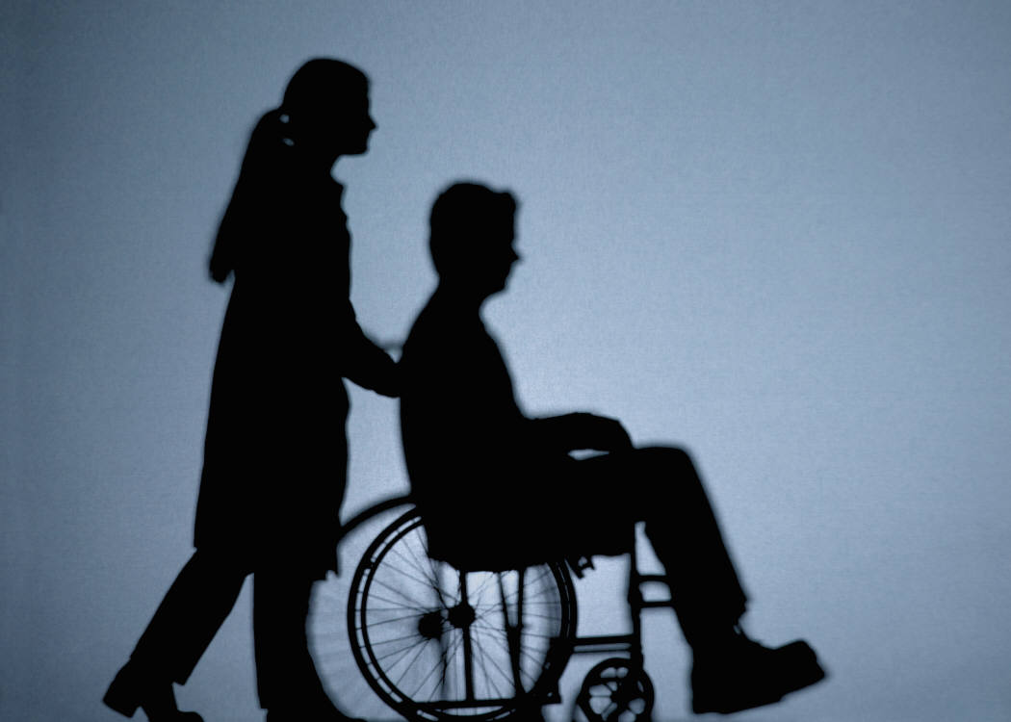

This area is intended to assess the person’s vulnerability in terms of personal care and daily living skills. Areas for consideration would include the following:
- identifying self, telephone number, address, etc.
- communicating needs,
- daily living skills,
- hygiene,
- ability to bathe,
- dental care,
- toileting,
- capacity to follow directions from health/medical providers,
- use of adaptive equipment,
- mobility/accessibility issues,
- dependence on staff for eating/drinking,
- need for staff supervision or personal assistance,
- making good choices for personal care,
- maintaining safely functioning adaptive equipment,
- other areas of concern

Safety/Risk Areas  Each area includes a list of indicators for possible risk or concern relating to the individual | Description of Concern  (Indicate “Yes” or “No” for each area listed. If “Yes”, write a brief narrative of the specific issue or concern posing a risk, the circumstances and frequency.) | Supports/Action Necessary to Address Risk/Safety Concerns  (Describe interventions or services necessary to address each identified safety/risk area) | Person Responsible and Timeframe  (List name and start date for implementation) | Evaluation of Effectiveness  (Describe what worked, what didn’t, person’s impressions of intervention and comments of others)

9. Personal Care/Daily Living
Areas for consideration…

Safety/Risk Assessment Areas

- Mental Health
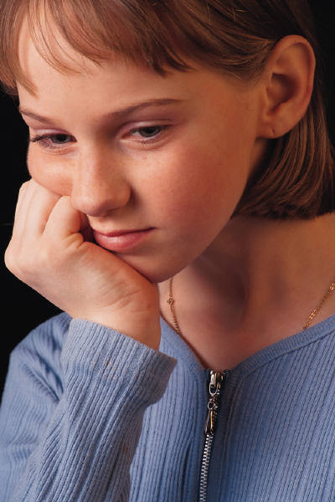

This area is intended to assess the person’s history or current issues relating to any mental health concerns. Areas for consideration would include the following:

- capacity/cognition,
- depression,
- screening to identify areas of treatment need,
- access to specialists for treatment,
- evaluation/assessment,
- dual diagnosis,
- medical counseling,
- refusal or inconsistent administration of psychotropic medications,
- refusal or inconsistent appointments with professionals,
- suicidal gestures/actions,
- psychiatric hospital admissions,
- lack of follow through on discharge plans,
- psychosocial stressors (losses, frequent moves, family problems, etc.),
- problems with substance abuse,
- other areas of concern…
Safety/Risk Areas  Each area includes a list of indicators for possible risk or concern relating to the individual | Description of Concern  (Indicate “Yes” or “No” for each area listed. If “Yes”, write a brief narrative of the specific issue or concern posing a risk, the circumstances and frequency.) | Supports/Action Necessary to Address Risk/Safety Concerns  (Describe interventions or services necessary to address each identified safety/risk area) | Person Responsible and Timeframe  (List name and start date for implementation) | Evaluation of Effectiveness  (Describe what worked, what didn’t, person’s impressions of intervention and comments of others)
10. Mental Health
Areas for consideration…

Safety/Risk Assessment Areas

- Police Involvement


This area is intended to assess the person’s criminal history or any police involvement. Areas for consideration would include the following:

history of criminal behavior,

illegal acts,

inappropriate calls to police,

fire setting,

vandalism,

causing harm to other people with disabilities,
- causing harm to others,
- poor judgment regarding continued relationships with problem individuals,
- making false accusations,
- court ordered services or supervision,
- domestic violence,
- probation status,
- other areas of concern

Safety/Risk Areas  Each area includes a list of indicators for possible risk or concern relating to the individual | Description of Concern  (Indicate “Yes” or “No” for each area listed. If “Yes”, write a brief narrative of the specific issue or concern posing a risk, the circumstances and frequency.) | Supports/Action Necessary to Address Risk/Safety Concerns  (Describe interventions or services necessary to address each identified safety/risk area) | Person Responsible and Timeframe  (List name and start date for implementation) | Evaluation of Effectiveness  (Describe what worked, what didn’t, person’s impressions of intervention and comments of others)

11. Police Involvement
Areas for consideration…

Safety/Risk Assessment Areas

- Informed Consent
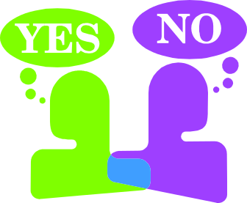

This area is intended to assess the person’s capacity to understand various types of information in order to make an informed decisions regarding his/her life and follow through for services necessary. Areas for consideration would include the following:

- medical and/or financial decision-making/power of attorney
- legal guardianship,
- ability to understand information,
- communication skills,
- need for information in alternative formats,
- capacity to make informed decisions in various areas such as day to day, medical, financial, etc.,
- ability to consent to durable powers of attorney for health care
- other areas of concern

Safety/Risk Areas  Each area includes a list of indicators for possible risk or concern relating to the individual | Description of Concern  (Indicate “Yes” or “No” for each area listed. If “Yes”, write a brief narrative of the specific issue or concern posing a risk, the circumstances and frequency.) | Supports/Action Necessary to Address Risk/Safety Concerns  (Describe interventions or services necessary to address each identified safety/risk area) | Person Responsible and Timeframe  (List name and start date for implementation) | Evaluation of Effectiveness  (Describe what worked, what didn’t, person’s impressions of intervention and comments of others)

12. Informed Consent
Areas for consideration…

Safety/Risk Assessment Areas

- Support Services
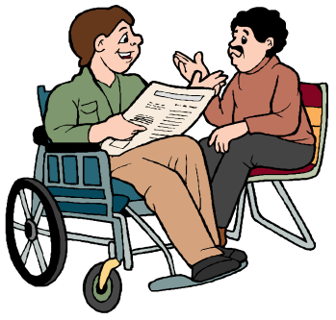

This area is intended to assess the person’s capacity to understand the need for various types of services or identify any potential family issues relating to any barriers/problems for the person to access any needed support services. Areas for consideration would include the following:
- the person signing his/her individual support plan,
- the person refusing or inconsistently accepting services,
- the family/caregiver refusing services,
- provider not available,
- natural supports available,
- lack of adequate supports available,
- other areas of concern

Safety/Risk Areas  Each area includes a list of indicators for possible risk or concern relating to the individual | Description of Concern  (Indicate “Yes” or “No” for each area listed. If “Yes”, write a brief narrative of the specific issue or concern posing a risk, the circumstances and frequency.) | Supports/Action Necessary to Address Risk/Safety Concerns  (Describe interventions or services necessary to address each identified safety/risk area) | Person Responsible and Timeframe  (List name and start date for implementation) | Evaluation of Effectiveness  (Describe what worked, what didn’t, person’s impressions of intervention and comments of others)

13. Support Services
Areas for consideration…

Safety/Risk Assessment Areas

- Other


This area is intended to describe any other safety issues not addressed in any of the previously mentioned areas.

Safety/Risk Areas  Each area includes a list of indicators for possible risk or concern relating to the individual | Description of Concern  (Indicate “Yes” or “No” for each area listed. If “Yes”, write a brief narrative of the specific issue or concern posing a risk, the circumstances and frequency.) | Supports/Action Necessary to Address Risk/Safety Concerns  (Describe interventions or services necessary to address each identified safety/risk area) | Person Responsible and Timeframe  (List name and start date for implementation) | Evaluation of Effectiveness  (Describe what worked, what didn’t, person’s impressions of intervention and comments of others)

14. Other
Areas for consideration…

Safety/Risk Areas | Probability for Serious Occurrence of Risk in this Area
- Community Safety
- Health/Medical
- Sexuality/Relationships
- Abuse
- Financial Exploitation
- Behaviors
- Home Environment
- Fire Safety
- Personal Care/Daily Living
- Mental Health
- Police Involvement
- Informed Consent
- Support Services
- Other

SUMMARY INFORMATION SHEET
Name of Person:________________________________________________ Date:____________________________

Instructions: Complete the Summary Information listed below AFTER the information included within this document has been completed.

Probability Code:

0 – Rare
1 – Unlikely
2 – Possible
3 – Likely
4 - Certain

Participants Involved in Planning Meeting

Name of Person: ______________________________________________ Date: __________________________

Support Broker: ___________________________________ Coordinator of Community Services: ________________________________

Family Participant(s): ______________________________________________________________________________________

Name of Person Completing this Form: ____________________________________ Title: __________________________

Names of Individuals Participating in or Providing Information for this Assessment:

Name: _________________________________ Title/Relationship: ________________________________

Name: _________________________________ Title/Relationship: ________________________________

Name: _________________________________ Title/Relationship: ________________________________

Name: _________________________________ Title/Relationship: ________________________________

Name: _________________________________ Title/Relationship: ________________________________

Name: _________________________________ Title/Relationship: ________________________________

Name: _________________________________ Title/Relationship: ________________________________

